**Zip Grade – Quick Guide**

|  |  |
| --- | --- |
| *Checklist before using pickers with students:*   * Create an account at [www.zipgrade.com](http://www.zipgrade.com) * Create classes and export your students from IC. * Print out answer sheets for your students. * Download the Zip Grade App on your smart phone or tablet. |  |

*Tips:*

* You create answer keys on the app on your phone.
* ZipGrade is perfect for summative assessments (tests, quizzes, exams, etc), but it is also works really well for sub plans or exit tickets.

Setting up Zipgrade at the beginning of the school year (Setting up ZipGrade each year is the most time consuming part. It will take 25-30 minutes.)

**In Infinite Campus…**

Step 1: On the left hand side, select **Custom Links and Reports.**

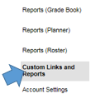

Step 2: Select **Student List Export for Quiz by Cours-Sec.**



Step 3: Set Calendar to **(your school name)** and pick a **Section (Class Period).**

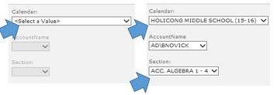

Step 4: Press “Apply,” in the bottom right hand corner.

Step 5: Select **Export** and **Excel** (under the Action tab)

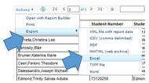

Step 6: Open the file in excel



Step 7: The file will open in Excel. Delete all of the columns except First Name, Last Name and Class.

**In ZipGrade…**

Step 1: Select **Classes. Add New Class.** Enter the Class Name (make sure it is the same as the class from the excel file). Click **Save Class.**

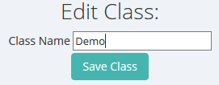

Step 2: Select **Students.**



Step 3: Import **Students from CSV.**



Using ZipGrade:

* Create a quiz (use the app)
* Print “scantrons” (use the web version)

Classes 🡪 Answer Sheet Packets 🡪 Print the PDF (make sure “double sided” is not selected on the copier)



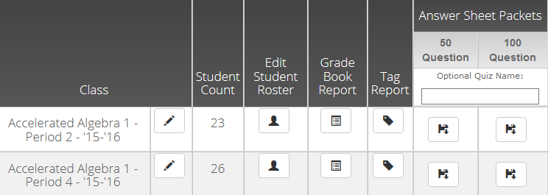

Grading (all within the app):

* Select the quiz your created
* Edit Key
* Scan Papers
* Review the statistics or item

|  |  |
| --- | --- |
|  |  |